### **Transformation in GIS**

As we know that raster data is obtained from many sources, such as satellite images, aerial cameras, and scanned maps. Modern satellite images and aerial cameras tend to have relatively accurate location information, but might need slight adjustments to line up with all our GIS data. Scanned maps and historical data usually do not contain spatial reference information. In these cases we will need to use accurate location data to align or georeference our raster data to a map coordinate system. A map coordinate system is defined using a map projection-a method by which the curved surface of the earth is portrayed on a flat surface.

When we georeference our raster data, we define its location using map coordinates and assign the coordinate system of the map frame. Georeferencing raster data allows it to be viewed, queried, and analyzed with our other geographic data.

In general, there are four steps to georeference data:

1. Add the raster dataset that we want to align with our projected data.
2. Use the **Georeference** tab to create control points, to connect our raster to known positions in the map
3. Review the control points and the errors
4. Save the georeferencing result, when we are satisfied with the alignment.

**Aligning the raster with control points**

Generally we will georeference our raster data using existing spatial data (target data), such as georeferenced rasters or a vector feature class that resides in the desired map coordinate system. The process involves identifying a series of ground control points—known x, y coordinates—that link locations on the raster dataset with locations in the spatially referenced data. Control points are locations that can be accurately identified on the raster dataset and in real-world coordinates. Many different types of features can be used as identifiable locations, such as road or stream intersections, the mouth of a stream, rock outcrops, and the end of a jetty of land, the corner of an established field, street corners, or the intersection of two hedgerows.

The control points are used in conjunction with the transformation to shift and warp the raster dataset from its existing location to the spatially correct location. The connection between one control point on the raster dataset (the from point) and the corresponding control point on the aligned target data (the two point) is a control point pair.

The number of links we need to create depends on the complexity of the transformation we plan to use to transform the raster dataset to map coordinates. However, adding more links will not necessarily yield a better registration. If possible, we should spread the links over the entire raster dataset rather than concentrating them in one area. Typically, having at least one link near each corner of the raster dataset and a few throughout the interior produces the best results.

Generally, the greater the overlap between the raster dataset and target data, the better the alignment results, because we'll have more widely spaced points with which to georeference the raster dataset. For example, if our target data only occupies one-quarter of the area of our raster dataset, the points we could use to align the raster dataset would be confined to that area of overlap. Thus, the areas outside the overlap area are not likely to be properly aligned. Keep in mind that our georeferenced data is only as accurate as the data to which it is aligned. To minimize errors, we should georeference to data that is at the highest resolution and largest scale for our needs.

**Transforming the raster**

When we've created enough control points, we can transform the raster dataset to the map coordinates of the target data. We have the choice of using several types of transformations, such as polynomial, spline, adjust, projective, or similarity, to determine the correct map coordinate location for each cell in the raster.

The polynomial transformation uses a polynomial built on control points and a **least-squares fitting (LSF)** algorithm. It is optimized for global accuracy but does not guarantee local accuracy.

**The polynomial transformation** yields **two formulas**:

1. One for computing the output x-coordinate for an input (x, y) location, and
2. One for computing the y-coordinate for an input (x, y) location.

Q. Write the necessity of least-squares fitting (LSF) algorithm for georeferencing.

The goal of the least-squares fitting algorithm is to derive a general formula that can be applied to all points, usually at the expense of slight movement of the positions of the control points. The number of the no correlated control points required for this method must be:

* 1 for a zero-order shift,
* 3 for a first order affine,
* 6 for a second order, and
* 10 for a third order.

The lower order polynomials tend to give a random type error, while the higher order polynomials tend to give an extrapolation error.

**A zero-order polynomial** is used to shift our data. This is commonly used when our data is already georeferenced, but a small shift will better line up our data. Only one control point is required to perform a zero-order polynomial shift. It may be a good idea to create a few control points, then choose the one that looks the most accurate.

**The first-order polynomial** transformation is commonly used to georeference an image. Use a first-order or affine transformation to shift, scale, and rotate a raster dataset. This generally results in straight lines on the raster dataset mapped as straight lines in the warped raster dataset. Thus, squares and rectangles on the raster dataset are commonly changed into parallelograms of arbitrary scaling and angle orientation.

Below is the equation to transform a raster dataset using the affine (first order) polynomial transformation. We can see how six parameters define how a raster's rows and columns transform into map coordinates.

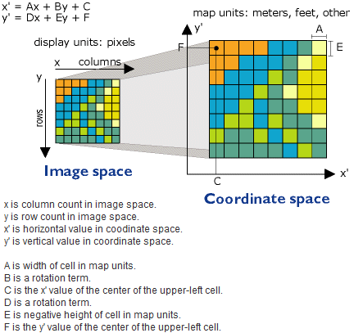

Q. Write the necessary equation to transform a raster dataset using the affine (first order) polynomial transformation with suitable diagram.

With a minimum of three control points, the mathematical equation used with a first-order transformation can exactly map each raster point to the target location. Any more than three control points introduces errors, or residuals, that are distributed throughout all the control points. However, we should add more than three control points, because if one control is inaccurate, it has a much greater impact on the transformation. Thus, even though the mathematical transformation error may increase as we create more links, the overall accuracy of the transformation will increase as well.

The higher the transformation order, the more complex the distortion that can be corrected. However, transformations higher than third order are rarely needed. Higher-order transformations require more links and, thus, will involve progressively more processing time.

In general, if our raster dataset needs to be stretched, scaled, and rotated, use a first-order transformation. If, however, the raster dataset must be bent or curved, use a second- or third-order transformation.

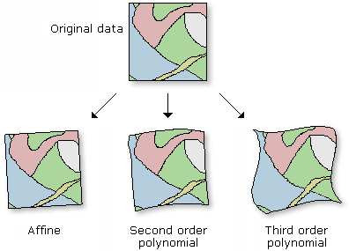

The adjust transformation optimizes for both global LSF and local accuracy. It is built on an algorithm that combines a polynomial transformation and **triangulated irregular network** (TIN) interpolation techniques. The adjust transformation performs a polynomial transformation using two sets of control points and adjusts the control points locally to better match the target control points using a TIN interpolation technique. Adjust requires a minimum of three control points.

The similarity transformation is a first order transformation which tries to preserve the shape of the original raster. The RMS error tends to be higher than other polynomial transformations since the preservation of shape is more important than the best fit. Similarity requires a minimum of three control points.

The projective transformation can warp lines so that they remain straight. In doing so, lines which were once parallel may no longer remain parallel. The projective transformation is especially useful for oblique imagery, scanned maps, and for some imagery products such as Landsat and Digital Globe. A minimum of four links are required to perform a projective transformation. When only four links are used, the RMS (root mean square) error will be zero. When more points are used, the RMS error will be slightly above zero. Projective requires a minimum of four control points.

The spline transformation is a true rubber sheeting method and optimizes for local accuracy but not global accuracy. It is based on a spline function, a piecewise polynomial that maintains continuity and smoothness between adjacent polynomials. Spline transforms the source control points exactly to target control points; the pixels that are a distance from the control points are not guaranteed to be accurate. This transformation is useful when the control points are important, and it is required that they be registered precisely. Adding more control points can increase overall accuracy of the spline transformation. Spline requires a minimum of 10 control points.

**Interpret the root mean square (RMS) error**

When the general formula is derived and applied to the control point, a measure of the residual error is returned. The error is the difference between where the from point ended up as opposed to the actual location that was specified. The total error is computed by taking the root mean square (RMS) sum of all the residuals to compute the RMS error. This value describes how consistent the transformation is between the different control points. When the error is particularly large, you can remove and add control points to adjust the error.

Although the RMS error is a good assessment of the transformation's accuracy, don't confuse a low RMS error with an accurate registration. For example, the transformation may still contain significant errors due to a poorly entered control point. The more control points of equal quality used, the more accurately the polynomial can convert the input data to output coordinates. Typically, the adjust and spline transformations give an RMS of nearly zero; however, this does not mean that the image will be perfectly georeferenced.

The forward residual shows you the error in the same units as the data frame spatial reference. The inverse residual shows you the error in the pixels units. The forward-inverse residual is a measure of how close your accuracy is, measured in pixels. All residuals closer to zero are considered more accurate.

**Geographical Transformation**

A geographical transformation is a mathematical operation that converts the coordinates of a point in one geographic coordinate system to the coordinates of the same point in another geographic coordinate system.

Since geographic coordinate systems contain [datums](http://wiki.gis.com/wiki/index.php/Datum) that are based on [spheroids](http://wiki.gis.com/wiki/index.php/Spheroid), a geographic transformation also changes the underlying spheroid. There are several methods, which have different levels of accuracy and ranges, for transforming between datums.

A geographic transformation always converts geographic (**latitude–longitude**) coordinates. Some methods convert the geographic coordinates to geocentric (X, Y, Z) coordinates, transform the X, Y, Z coordinates, and convert the new values back to geographic coordinates

Affine transformation is a geographic transformation that scales, rotates, skews, and/or translates images or coordinates between any two Euclidean spaces. It is commonly used in GIS to transform maps between coordinate systems.

In an affine transformation, parallel lines remain parallel, the mid-point of a line segment remains a mid-point and all points on a straight line remain on a straight line.

Geometric transformation is the process of using a set of control points and transformation equations to register a digitized map, satellite image, or an air photo to a projected coordination system.

Geometric transformation converts a newly digitized map into projected coordinates by a process called **map-to-map transformation**. A remotely sensed image is converted to projected coordinates using **image-to-map transformation**. This is also called **georeferencing**.

Different methods have been proposed for transformation from one coordinate system to another. Each method is differentiated based on the geometric property it preserves and the changes it allows. Transformation results in either:

* Changes in position and direction
* Uniform change of scale or
* Changes in size and shape

Below are listed the various transformations and their effect on a rectangular object:

1. **Equiarea transformation** permits rotation of rectangle and preserves its shape and size.
2. **Similarity transformation** permits rotation of rectangle and preserves its shape but not the size.
3. **Affine transformation** allows angular distortion but preserves parallelism of lines
4. **Projective transformation** allows both angular and length distortions and thus allows the rectangle to be transformed into an irregular quadrilateral.

Generally, **Affine transformations** are used for map-to-map or image-to-map transformations and projective transformation is used for aerial photographs with relief displacement.

**Geometric transformations**

Geometric transformations are needed to give an entity the needed position, orientation, or shape starting from existing position, orientation, or shape. The basic transformations are scaling, rotation, translation, and shear. Other important types of transformations are projections and mappings.

**Map-To-Map Transformation**

* Geometric transformation converts a newly digitized map into projected coordinates
* A manually-digitized map has the same measurement as its source map: measured in inches
* A converted scanned image of the map is measured in dots per inch (dpi)
* To make the digitized map usable in GIS – it must be converted into a projected coordinate system to align with other layers Geometric transformation also applies to satellite imagery.

**Image-To-Map Transformation**

* Remotely sensed data transformation involves changing row and columns
* Can spatially register a georeferenced image in a GIS database
* Must have same coordinate system
* The rows and columns can be transformed into a projected coordinate system.

**Affine transformation**

The affine transformation allows rotation, translation, skew, and differential scaling on a rectangular object, while preserving line parallelism (Pettofrezzo 1978; Loudon, Wheeler, and Andrew 1980; Chen, Lo, and Rau 2003).

* Rotation rotates the object’s x- and y-axes from the origin.
* Translation shifts its origin to a new location.
* Skew allows a no perpendicularity (or affinity) between the axes, thus changing its shape to a parallelogram with a slanted direction, and
* Differential scaling changes the scale by expanding or reducing in the x and/or y direction.

**Figure** shows these four transformations graphically.

Mathematically, the affine transformation is expressed as a pair of first-order polynomial equations:

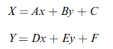

where x and y are the input coordinates that are given; X and Y are the output coordinates to be determined; and A, B, C, D, E, and F are the transformation coefficients

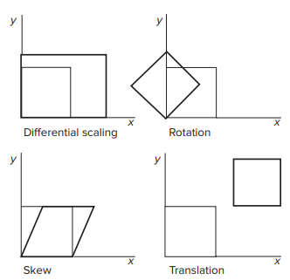

**Figure**: Differential scaling, rotation, skew, and translation in the affine transformation.

The same equations apply to both digitized maps and satellite images. But there are two differences. First, x and y represent point coordinates in a digitized map, but they represent columns and rows in a satellite image. Second, the coefficient E is negative in the case of a satellite image. This is because the origin of a satellite image is located at the upper-left corner, whereas the origin of a projected coordinate system is at the lower-left corner.

Operationally, an affine transformation of a digitized map or image involves three steps **(Figure**). First, update the x- and y-coordinates of selected control points to real-world (projected) coordinates. If real-world coordinates are not available, we can derive them by projecting the longitude and latitude values of the control points. Second, run an affine transformation on the control points and examine the RMS error. If the RMS error is higher than the expected value, select a different set of control points and rerun the affine transformation. If the RMS error is acceptable, then the six coefficients of the affine transformation estimated from the control points are used in the next step. Third, use the estimated coefficients and the transformation equations to compute the new x- and y-coordinates of map features in the digitized map or pixels in the image. The outcome from the third step is a new map or image based on a user-defined projected coordinate system.

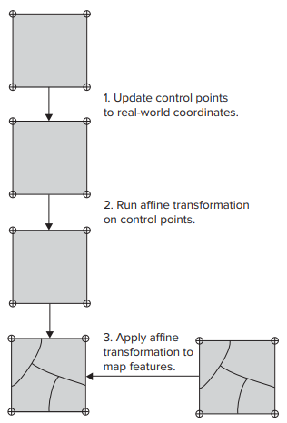

**Figure**: A geometric transformation typically involves three steps. **Step 1** updates the control points to real-world coordinates. **Step 2** uses the control points to run an affine transformation. **Step 3** creates the output by applying the transformation equations to the input features.

[**Affine transformation**](https://www.mathworks.com/help/images/ref/affine2d.html) is a linear mapping method that preserves points, straight lines, and planes. Sets of parallel lines remain parallel after an affine transformation.

The affine transformation technique is typically used to correct for [geometric distortions or deformations](https://www.mathworks.com/help/images/geometric-transformations.html) that occur with non-ideal camera angles. For example, satellite imagery uses affine transformations to correct for wide angle lens distortion, panorama stitching, and image registration. Transforming and fusing the images to a large, flat coordinate system is desirable to eliminate distortion. This enables easier interactions and calculations that don’t require accounting for image distortion.

The following table illustrates the [different affine transformations](https://www.mathworks.com/help/images/2-d-and-3-d-geometric-transformation-process-overview.html#f12-31782): translation, scale, shear, and rotation.

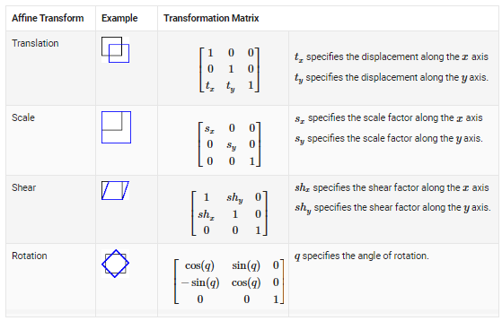

**Questions**

1. Write the necessity of least-squares fitting (LSF) algorithm for georeferencing. 2-3
2. Write the necessary equation to transform a raster dataset using the affine (first order) polynomial transformation with suitable diagram. 5
3. Explain map-to-map transformation and image-to-map transformation. 3
4. The affine transformation allows rotation, translation, skew, and differential scaling. Describe each of these transformations. 3-4
5. Operationally, an affine transformation involves three sequential steps. What are these steps? Explain with a diagram. 2-3
6. Define the RMS error in geometric transformation. 2-3
7. Explain the role of the RMS error in an affine transformation. 2-3